Generation of Fire Sprinkler drawing in AutoCAD - POC

1. Overview
This document defines the system architecture for integrating AutoCAD with the NashZero MEP Design Engine to enable automated Fire Sprinkler design generation from architectural drawings.
The POC enables:
- Extraction of architectural parameters within AutoCAD from a “Standard architecture drawing”
- Additional (in addition to parameters available in Architecture drawing) mandatory parameters to be collected from the user.
- Convert the Architecture and user defined parameters into a structured Json
- Secure transmission of structured data to NashZero
- Engineering computation or Fire sprinkler data in the NashZero backend
- Automated drafting of Fire sprinkler details in AutoCAD
Standard architecture drawing will have the necessary details drafted as per the standard with labels in it so that the AutoCAD plugin can extract the details in a straightforward manner.

2. Flow Diagram 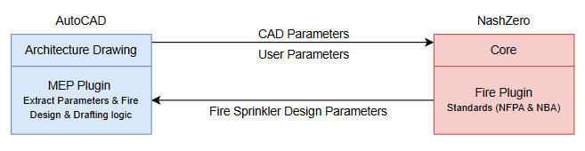

2.1 Data Flow
- AutoCAD → sends design + parameters
- API Layer → transfers data
- Nash Fire Plugin → computes results
- Output → sent back to AutoCAD
- AutoCAD → Design & Draft Fire Sprinkler layout

3. Prototype requirement
- Compute Fire Sprinkler parameters based on Architectural & user parameters
- Individual Layout Creation
- Co-ordinated layouts
- Extract individual layout after co-ordnation
4. Action Items
- Provide Architectural base drawing – Ashok
- Provide Reference Fire sprinkler layout – Ashok
- Design logic cum parameters - Ashok
- Necessary input parameters to be supplied from AutoCAD – Ashok
- Document the discussion points – Saravana
- Build extract parameters logic – Saravana
- Draft Fire sprinkler drawing - Saravana

